Compiler Construction Lab – Week 9 Submission



Session: 2022 – 2026

Submitted by:
Muhammad Tayyab
2022-CS-133

Submitted to:
Miss Aliya Farooq

Department of Computer Science
University of Engineering and Technology
Lahore Pakistan

Lab Report: Lexical Analysis via NFA Design

1. Lab Objective
The primary purpose of this laboratory session was to apply the theoretical principles of lexical analysis in the context of compiler design. The specific aim was to construct a Lexical Scanner by designing a Nondeterministic Finite Automaton (NFA)—first manually, and then digitally—to correctly identify and classify various tokens within a source language.

2. NFA Creation and JFLAP Utilization (Parts 1 & 2)

2.1 Design Concept
We utilized a state-based approach to design an NFA capable of distinguishing between fundamental linguistic elements such as keywords, identifiers, numerical constants, and operators. The design strategy involved establishing a central start state that branches into distinct transition paths, each corresponding to the structural pattern of a specific token type.

2.2 Implementation in JFLAP
Following the manual design phase, the NFA was modeled digitally using the JFLAP software tool. This step was crucial for validating the logic of the automaton. By running simulations within JFLAP, we were able to verify that the NFA correctly accepted valid input strings and properly categorized them into their respective token classes.
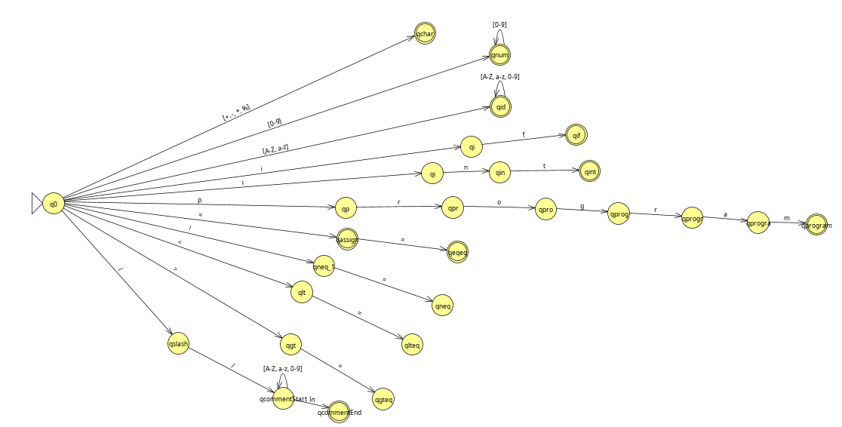
Figure 1: JFLAP Implementation of Lexical Analysis NFA
2.3 Path Breakdown
As illustrated in Figure 1, the NFA initiates at the start state (q0​) and diverges into specialized branches to handle different inputs:
- Keywords (e.g., "class"): A specific sequence of transitions is dedicated to reserved words. For the keyword "class," the NFA navigates through a defined path (e.g., states q5​ through q9​) that only accepts that exact string of characters.
- Identifiers: The branch responsible for variable names begins with a transition to an intermediate state (e.g., q4​). This path allows for combinations of letters or underscores, ultimately terminating at an accepting state (e.g., q1​) to validate standard identifiers.
- Numeric Constants: To recognize integers, a transition leads from q0​ to a number-processing state (e.g., q2​). This state directs the flow to an accepting state (e.g., q3​) upon reading a digit and includes a loop to accommodate multi-digit numbers.
- Operators: The NFA handles mathematical and logical symbols through distinct sub-paths:
  - Relational: Specific branches (e.g., originating from q17​ and q10​) are configured to detect comparison operators such as <, <=, >, and >=.
  - Arithmetic: Separate transitions are assigned to basic math symbols, guiding inputs for + and - to their respective accepting states (e.g., via q13​ through q16​).

3. Stateless Approach and Transition Table (Part 3)
3.1 The Stateless Concept
The stateless approach (or table-driven approach) decouples the scanner's control flow logic from the specific grammar of the language. Instead of maintaining separate code blocks for each state, the scanner uses a generic driver loop and a transition table to determine the next action ⁸. To achieve this in JFLAP, the NFA was converted into a Deterministic Finite Automaton (DFA) to eliminate ambiguity.

3.2 Transition Table Design
Below is the transition table designed for the MicroJava tokens. The rows represent the current state, and the columns represent the input character⁹.
State | Description | Letter | Digit | / | = | ! | < | > | Other Op | EOL
0 | Start | 1 | 2 | 3 | 5 | 7 | 9 | 11 | 13 | 0
1 | ID | 1 | 1 | [RET] | [RET] | [RET] | [RET] | [RET] | [RET] | [RET]
2 | Num | [RET] | 2 | [RET] | [RET] | [RET] | [RET] | [RET] | [RET] | [RET]
3 | Div/Comm | [RET] | [RET] | 4 | [RET] | [RET] | [RET] | [RET] | [RET] | [RET]
4 | Comment | 4 | 4 | 4 | 4 | 4 | 4 | 4 | 4 | 0
5 | Assign? | [RET] | [RET] | [RET] | 6 | [RET] | [RET] | [RET] | [RET] | [RET]
6 | Eq (==) | [RET] | [RET] | [RET] | [RET] | [RET] | [RET] | [RET] | [RET] | [RET]
7 | Not? | Err | Err | Err | 8 | Err | Err | Err | Err | Err
8 | Neq (!=) | [RET] | [RET] | [RET] | [RET] | [RET] | [RET] | [RET] | [RET] | [RET]
(Note: [RET] indicates the token is complete and the scanner returns the type associated with the previous state.)

3.3. Comparison of Approaches
Per the lab objective, the state-based and stateless approaches were compared regarding simplicity and efficiency.
Feature | State-Based (Manual Code) | Stateless (Table-Driven)
Simplicity | Logic is intuitive for small languages (e.g., if (input == 'a')). However, the code becomes complex and repetitive as the grammar grows. | The code remains simple and generic regardless of grammar size. The complexity resides entirely in the data (the table).
Efficiency | Execution Speed: Faster, as transitions are hard-coded jumps or switch statements. | Execution Speed: Slightly slower due to memory access overhead (array lookups).
Maintenance | Low flexibility. Modifying tokens requires rewriting code logic. | High flexibility. Modifying tokens only requires updating the table entries.

